We have been given the opportunity to have made to order Shag Plaques In three designs.
You can personalize with your name as MASON, initials JMJ or a word as in SHAG.
This is a fundraiser opportunity for the WSSC. Juan Pino, one of our club members,
has graciously offered to make these for us. There are three designs, two with shaggers and one Jukebox.
Made to order with a primer at a cost of $48.00. With the primer you can paint the plaque whatever color you wish.
If you prefer it painted in a black or white by Juan, that can be done at an additional cost of $10
Delivery will be waived if you pick the finished product up at the club. If you want it shipped or delivered that extra cost will be $15.
This is a wonderful opportunity for our club and members. I have a sample available to view and taking orders.
Checks should be made out to Winston Salem shag club and of course, cash is always accepted.
If you are interested in the many other patterns Juan has available, you can order directly from Juan cost beginning at $58.

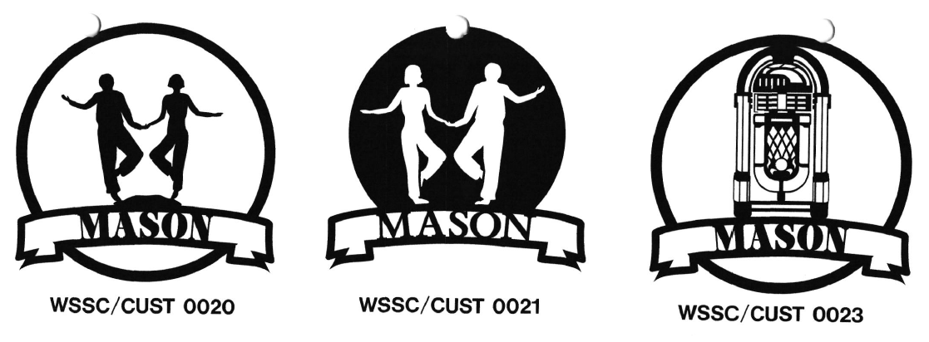
If you are interested in ordering, please see me at the club, email me or call.
Janet Mason masonjanet1976@gmail.com 336-403-6433

